Day 23 - 17th Aug 2026

Out of 28 Tasks … 14 tasks i.e 1 of each task are in session tasks and rest 2nd of each topic is a home task.

🏗 Brownfield vs. Greenfield
- What distinguishes a Brownfield application from a Greenfield one in terms of constraints and opportunities?
Aspect | Brownfield | Greenfield
Meaning | Existing application being modified or modernized | New application built from scratch
Constraints | Legacy code, technical debt, existing data, integrations | Very few legacy constraints
Technology Choice | Often limited by existing technologies | Can choose modern technologies freely
Architecture | Must work with existing architecture | Can design architecture from scratch
Risk | Higher due to dependencies and unknown issues | Usually lower from legacy perspective
Migration Approach | Usually gradual and incremental | Can be built directly toward the target state
Opportunity | Improve an existing system while preserving business value | Build an optimized system using modern practices
Example | Modernizing a 10-year-old Java banking application | Building a new banking application using Spring Boot and microservices

- Why might modernization of a Brownfield system be more complex than building a Greenfield solution?
💼 Business Drivers
- How do business drivers such as cost reduction, agility, and compliance influence migration decisions?
Business drivers determine why an application should be migrated and what strategy should be used.
Business Driver | Influence on Migration Decision
Cost Reduction | Encourages moving to cloud, managed services, or more efficient infrastructure to reduce operational and maintenance costs.
Agility | Encourages modernization, cloud adoption, APIs, and CI/CD so the business can release features faster.
Compliance | May require migration to platforms with better security, auditing, encryption, and regulatory support.
Scalability | Encourages cloud or scalable architectures that can handle changing workloads efficiently.
Business Continuity | Encourages migration to infrastructure with better backup, disaster recovery, and availability.

- Can modernization be justified purely on technical grounds without business drivers? Why or why not?
📊 Application Portfolio Assessment
- What is the purpose of conducting an application portfolio assessment before migration?
The purpose of an Application Portfolio Assessment is to evaluate existing applications and decide which applications should be migrated, modernized, replaced, retired, or retained.
• Understand the current state – applications, technologies, dependencies, and infrastructure.
• Identify risks – technical debt, security issues, outdated technologies, etc.
• Evaluate business value – determine which applications are critical to the business.
• Choose the right migration strategy – Rehost, Replatform, Refactor, Repurchase, Retire, or Retain.
• Estimate cost and effort – understand migration complexity and expected investment.
• Prioritize applications – decide which applications should be migrated first.

- How does inventorying applications and dependencies reduce risk during modernization?
🔍 Discovery & Mapping
- Why is mapping integration points critical when planning migration?
Mapping integration points is critical because applications rarely work in isolation. They often depend on databases, APIs, external systems, messaging systems, and other applications.
Reason | Why It Matters
Identify Dependencies | Shows which systems communicate with the application.
Avoid Breakages | Prevents migration from accidentally breaking existing integrations.
Plan Migration Order | Helps determine which applications should be migrated first or together.
Data Flow Understanding | Shows how data moves between systems.
Security & Compliance | Identifies sensitive data transfers and authentication requirements.
Testing | Helps define integration tests needed after migration.

- How can overlooked dependencies derail a migration project?
⚖️ Technical Debt & Stack Evaluation
- How does technical debt impact modernization strategy selection?
Technical debt affects how much modernization is needed and which migration strategy is suitable.
Technical Debt Level | Likely Strategy
Low | Rehost/Replatform may be sufficient
Moderate | Replatform or Refactor to improve the application
High | Refactor, Rewrite, Repurchase, or Retire may be more appropriate
Very High + Low Business Value | Retire or Replace the application
Higher technical debt usually means more modernization effort, higher risk, and a greater need to move beyond simple migration strategies.

- What role does evaluating runtime dependencies play in migration planning?
🗄 Database & Infrastructure
- What are the main risks in database migration, and how can they be mitigated?
The main risks in database migration are data loss, corruption, downtime, compatibility issues, and performance problems.
Risk | Mitigation
Data Loss/Corruption | Take backups, validate data, and perform reconciliation after migration.
Downtime | Use replication, CDC (Change Data Capture), or phased migration to reduce downtime.
Data Inconsistency | Perform data validation and synchronization before cutover.
Schema/Compatibility Issues | Analyze schema differences and test queries, procedures, and applications beforehand.
Performance Issues | Load-test the target database and optimize indexes/queries.
Security/Compliance Issues | Encrypt data, control access, and validate security requirements.
Rollback Difficulty | Maintain backups and prepare a tested rollback plan.
In short: Database migration should be planned, tested, backed up, validated, and performed with a clear rollback strategy.

- How does hosting infrastructure assessment influence cloud-readiness decision
🔐 Security & Compliance
- Why must security and compliance be reassessed during migration, even if the application was previously compliant?
Because migration changes the application’s environment, architecture, data flow, and security controls. Previous compliance does not automatically carry over to the new environment.
Reason | Why It Matters
New Infrastructure | Cloud or new infrastructure may have different security configurations.
Data Movement | Data may now travel through new networks, APIs, or regions.
Access Control | Users, roles, IAM policies, and permissions may change.
Encryption | Encryption requirements must be revalidated for data at rest and in transit.
Compliance Requirements | Regulations may impose requirements on data location, retention, logging, and auditing.
New Dependencies | New third-party services or cloud providers can introduce additional risks.

- How does modernization affect risk posture?
🔄 Migration Strategies (6 R’s)
- How do the 6 R’s of migration provide a framework for decision-making?

The 6 R’s of Migration provide a structured way to decide what to do with each application based on its business value, technical condition, cost, and complexity.
6 R | Decision
Rehost | Move the application as-is with minimal changes.
Replatform | Move it with small optimizations to take advantage of the new platform.
Refactor | Redesign/rewrite parts of the application to improve scalability, performance, or maintainability.
Repurchase | Replace the application with a commercial/SaaS product.
Retire | Remove the application because it is no longer needed.
Retain | Keep the application as it is because migration is not currently justified.

- In what scenario would refactoring be preferable to rehosting?
📈 Cost & Effort Analysis
- How does TCO (Total Cost of Ownership) differ from upfront migration cost?
Aspect | Upfront Migration Cost | TCO (Total Cost of Ownership)
Meaning | Cost required to perform the migration | Total cost of owning and operating the application over a period
Includes | Migration tools, development, testing, data transfer, consultants | Infrastructure, licenses, maintenance, support, operations, migration, training, etc.
Time Period | Mainly one-time | Long-term
Purpose | Estimate the cost of moving the application | Evaluate the overall financial impact
Example | ₹5 lakh to migrate an application to cloud | ₹5 lakh migration + ₹10 lakh/year for cloud, support, licenses, and maintenance

- Why is effort, complexity, and risk scoring essential for prioritization?
🗂 Prioritization & Planning
- What factors determine wave planning for application migration?
Wave planning determines the order and grouping in which applications are migrated, usually to reduce risk and avoid disrupting business operations.
Factor | How it Influences Wave Planning
Business Criticality | Less critical applications are often migrated first; critical systems may come later.
Dependencies | Applications with shared databases, APIs, or services may need to be migrated together or in a specific order.
Complexity | Simple applications can be used as early migration candidates to gain experience.
Risk | High-risk applications require more planning, testing, and sometimes later migration waves.
Business Impact | Systems with strict availability requirements need careful scheduling.
Technical Readiness | Applications that are cloud-ready can usually be migrated earlier.
Resources | Available teams, skills, budget, and migration tools affect how many applications can be handled in each wave.
Migration Strategy | Rehost, Replatform, Refactor, etc. can require different timelines and resources.

- How does prioritization balance business urgency with technical feasibility?
🏛 Target-State Architecture & Patterns
- How does defining a target-state architecture guide modernization choices?

Defining a target-state architecture describes what the application should look like after modernization. It provides a clear direction for choosing technologies, architecture, and migration strategies.
Factor | How It Guides Modernization
Architecture | Determines whether to use monolith, microservices, serverless, etc.
Technology | Helps select appropriate modern frameworks, databases, and platforms.
Cloud Strategy | Defines how cloud services, containers, and infrastructure will be used.
Integration | Defines how APIs, messaging, and external systems should communicate.
Security | Establishes required authentication, authorization, encryption, and monitoring.
Scalability | Ensures the new design can handle future growth.
Migration Strategy | Helps decide whether to Rehost, Replatform, Refactor, etc.

- Compare the Strangler Fig pattern with the Anti-Corruption Layer in terms of risk mitigation.
📦 Containerization & Cloud-Readiness
- What are the key indicators that an application is cloud-ready?
An application is cloud-ready when it can run effectively in a cloud environment with minimal changes and can take advantage of cloud capabilities.
Indicator | What It Means
Scalability | Can scale resources up/down based on demand.
Stateless Design | Application instances don't depend heavily on local session/state.
Externalized Configuration | Configuration and secrets are separated from application code.
Containerization | Can be packaged and run consistently using containers.
API-Based Integration | Communicates with other systems through well-defined APIs.
Automated Deployment | Supports CI/CD and automated infrastructure/deployment.
Observability | Has proper logging, monitoring, health checks, and metrics.
Resilience | Can handle failures and recover without major disruption.
Security | Supports modern identity, access control, encryption, and secret management.

- How does containerization support modernization goals?
📏 Success Metrics & Roadmap
- Why are KPIs critical in measuring migration success?

KPIs (Key Performance Indicators) are critical because they provide measurable evidence that the migration achieved its business and technical objectives.
KPI | What It Measures
Cost | Whether migration reduced operational/TCO costs
Performance | Response time, throughput, and application performance
Availability | System uptime and reliability
Migration Time | Whether migration was completed within the planned timeline
Downtime | Business disruption during migration
Security | Security incidents and compliance status
User Experience | Whether application usability and satisfaction improved
Deployment Frequency | Whether modernization improved release speed

- How does a migration roadmap align technical execution with business case justification?
🛠 Tools & Documentation
- What role do assessment tools play in reducing subjectivity during migration planning?
Assessment tools help make migration planning data-driven and consistent instead of relying only on personal opinions or assumptions.
Role | How It Helps
Data Collection | Automatically gathers information about applications, infrastructure, dependencies, and usage.
Standardized Scoring | Uses consistent criteria to score complexity, risk, cost, and business value.
Dependency Analysis | Identifies relationships between applications, databases, APIs, and services.
Risk Identification | Highlights technical debt, outdated technologies, security issues, and migration risks.
Comparison | Allows different applications to be evaluated using the same criteria.
Decision Support | Provides evidence for choosing migration strategies and priorities.

- Why is documenting findings essential for stakeholder buy-in?

—---------------------------------------------------------------------------------------
10.25 to 10.45 – complete tasks ..
Till 11 am (10.45 to 11 break)

Redis:
Task 1:
What is Redis used for ? why ?
Redis (Remote Dictionary Server) is an in-memory data store commonly used as a cache, session store, message broker, and fast database.
Redis is an in-memory key-value data store mainly used for caching, session management, real-time counters, messaging, and other low-latency operations. It is used because storing data in memory makes read/write operations extremely fast and helps reduce the load on the primary database.

Task 2.:
Can you explain the architecture of Redis with a diagram?
11.37 to 11.42

Redis follows a client-server architecture where clients communicate with a Redis server to store and retrieve data.

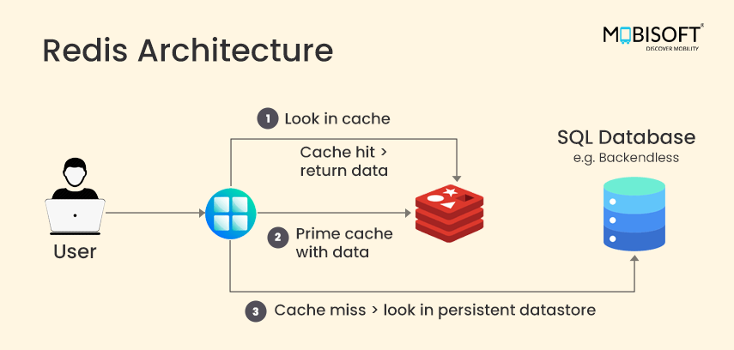

- Client
  - Application sends commands such as GET, SET, DEL.
  - Example:
SET user:101 "Pavan"
- Redis Server
  - Processes client commands.
  - Stores data primarily in RAM.
  - This is why Redis is very fast.
- In-Memory Data
  - Data is stored as key-value pairs.
  - Example:
user:101 → Pavan
- Persistence
  - Redis can save data to disk using RDB or AOF.
  - This helps recover data after a restart.
- Replication
  - A Redis primary can replicate data to one or more replicas.
  - Helps with availability and read scaling.
- Clustering
  - Redis Cluster can distribute data across multiple Redis nodes.
  - Useful when a single server isn't enough.
In one line
Client → Redis Server → RAM (fast access), with optional Disk Persistence, Replication, and Clustering.

Task 3:
What are the advantages of redis and also disadvantages?
11.43 to 11.46
Advantages
- Very Fast – Stores data primarily in RAM, providing low-latency access.
- Simple Key-Value Model – Easy to store and retrieve data using keys.
- Supports Multiple Data Types – Supports Strings, Lists, Sets, Hashes, Sorted Sets, Streams, etc.
- Reduces Database Load – Frequently accessed data can be served from Redis instead of the main database.
- Scalable – Supports replication and Redis Cluster for scaling.
- Useful for Real-Time Applications – Suitable for caching, counters, leaderboards, sessions, and messaging.
- Persistence Support – Can save data to disk using RDB and AOF.
Disadvantages
- Memory Cost – RAM is more expensive than disk storage.
- Limited by Available RAM – Large datasets may require significant memory.
- Data Loss Risk – If persistence is not configured properly, data can be lost after a failure.
- Not Ideal for Complex Queries – It does not provide the rich querying capabilities of relational databases.
- Single-Node Limitations – A standalone Redis server has limited memory and processing capacity.
- Operational Complexity – Clustering, replication, persistence, and failover require proper configuration.
- Not Always Suitable as a Primary Database – For many applications, Redis is better used alongside a durable database like PostgreSQL or MongoDB.

Task 4:
Install docker in your system

Steps
- Download from https://www.docker.com/products/docker-desktop
- Run installer
- Enable hyper-v
- Restart the system
- Check docker version in cmd
  - docker –version
- Done installed docker ..

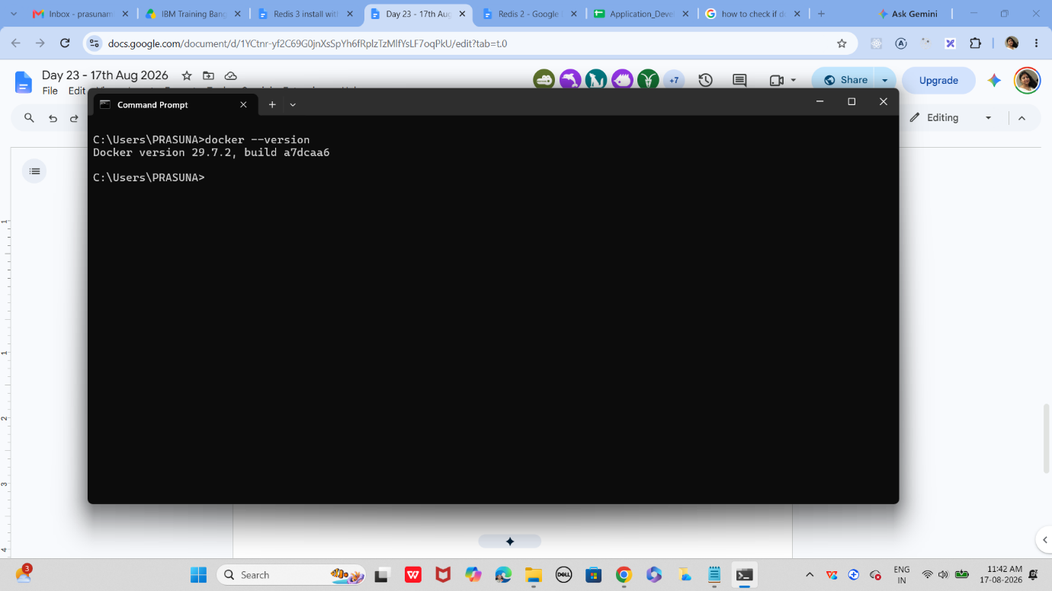

Task 5:
Open docker from the start menu
Now check
Docker version
It should show
Client and server version information like the below ss

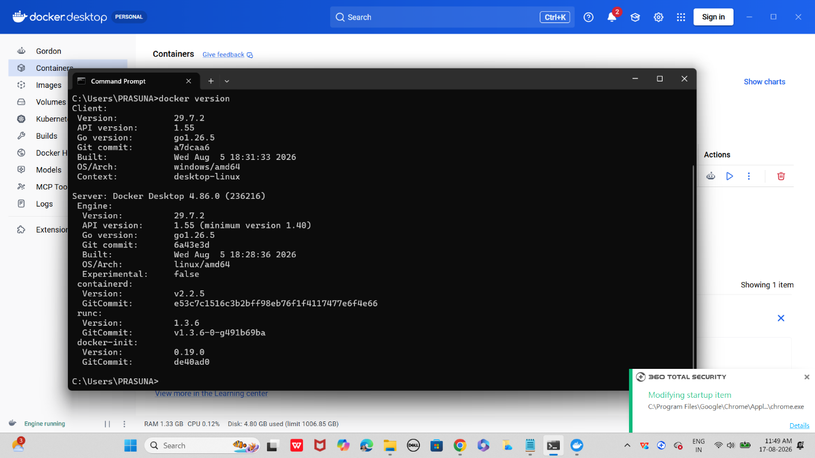

Use command to pull image
docker pull redis

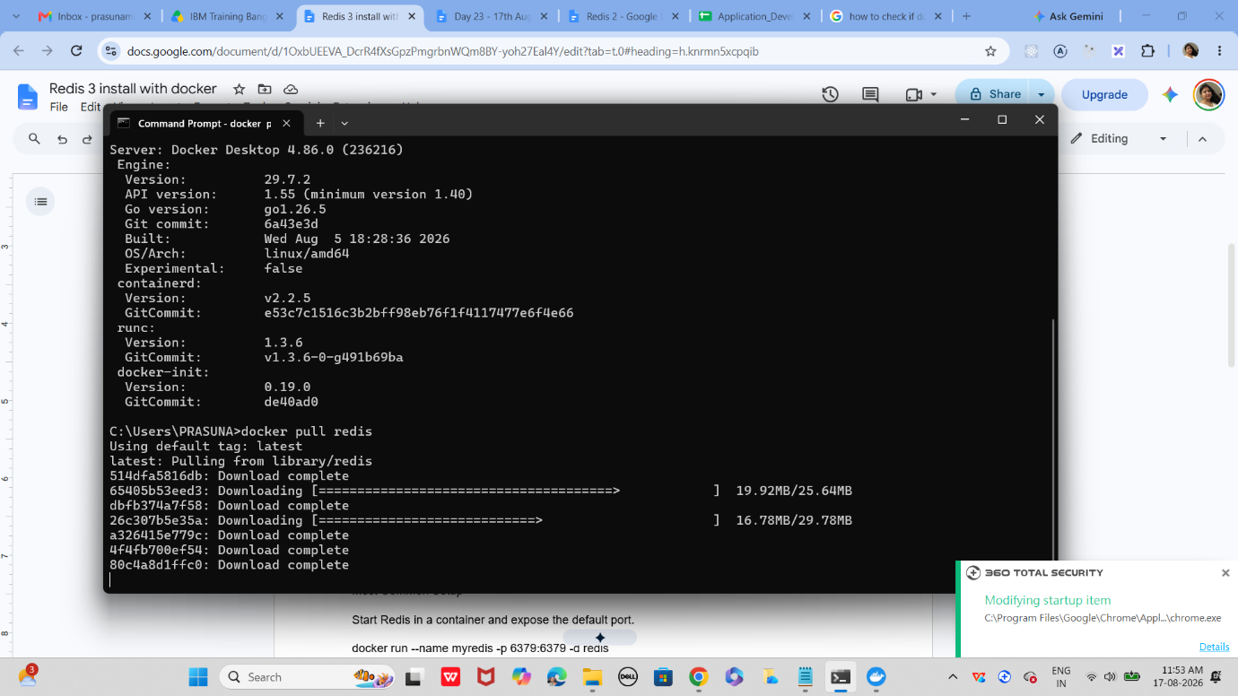
If pull is success

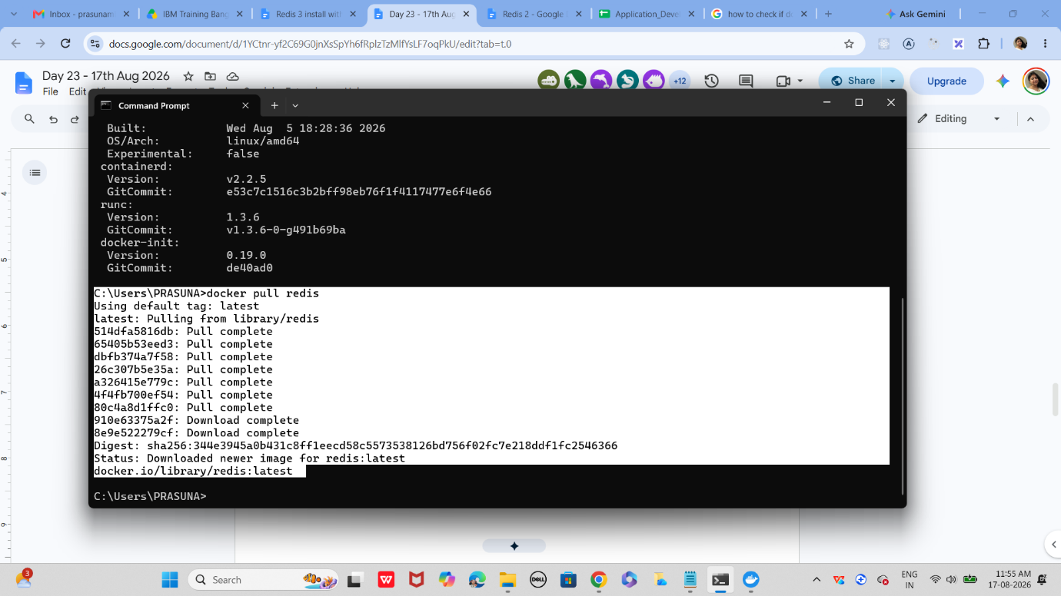

Use the command to check image

Docker images



Task 6:

Now run redis container

docker run --name myredis -p 6379:6379 -d redis
Myredis is the name of the container i m creating you can give ur own
-p 6379:6379 this will map the port no to th local host.
-d redis means we RE RUNNING IN detached mode..
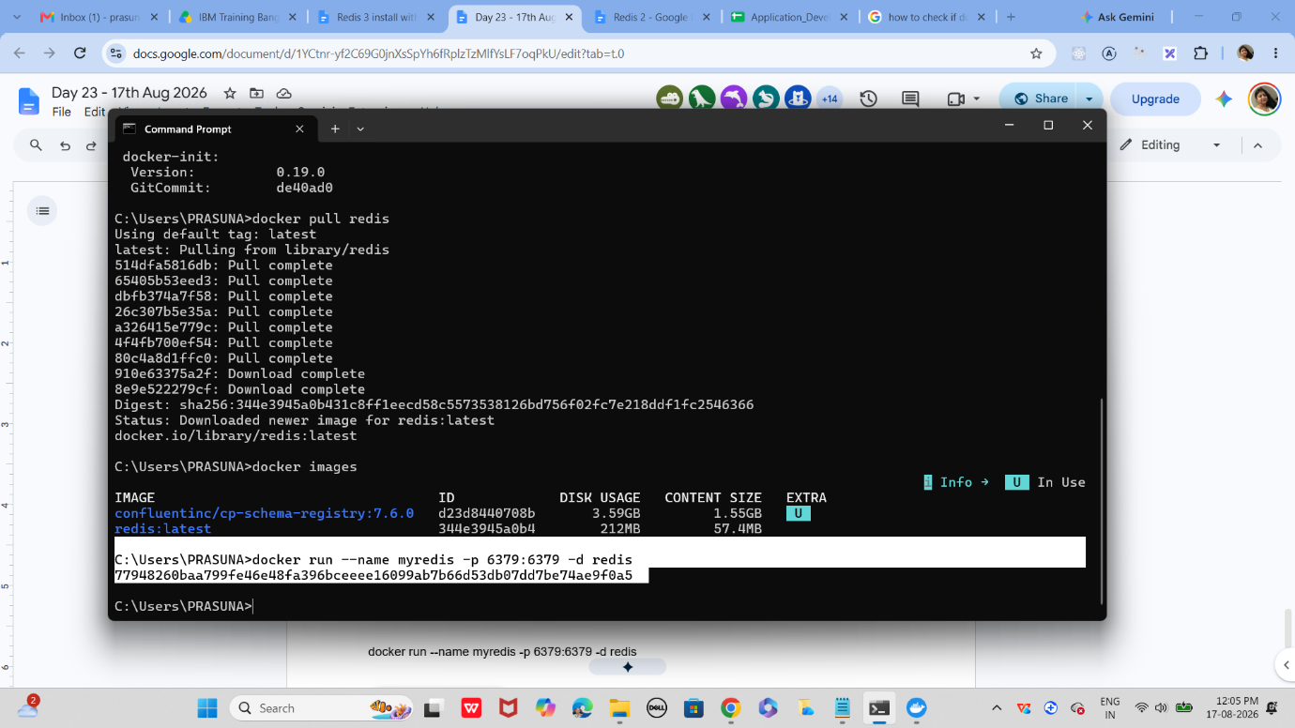
Task 7:
Now will test the connection
docker exec -it myredis redis-cli
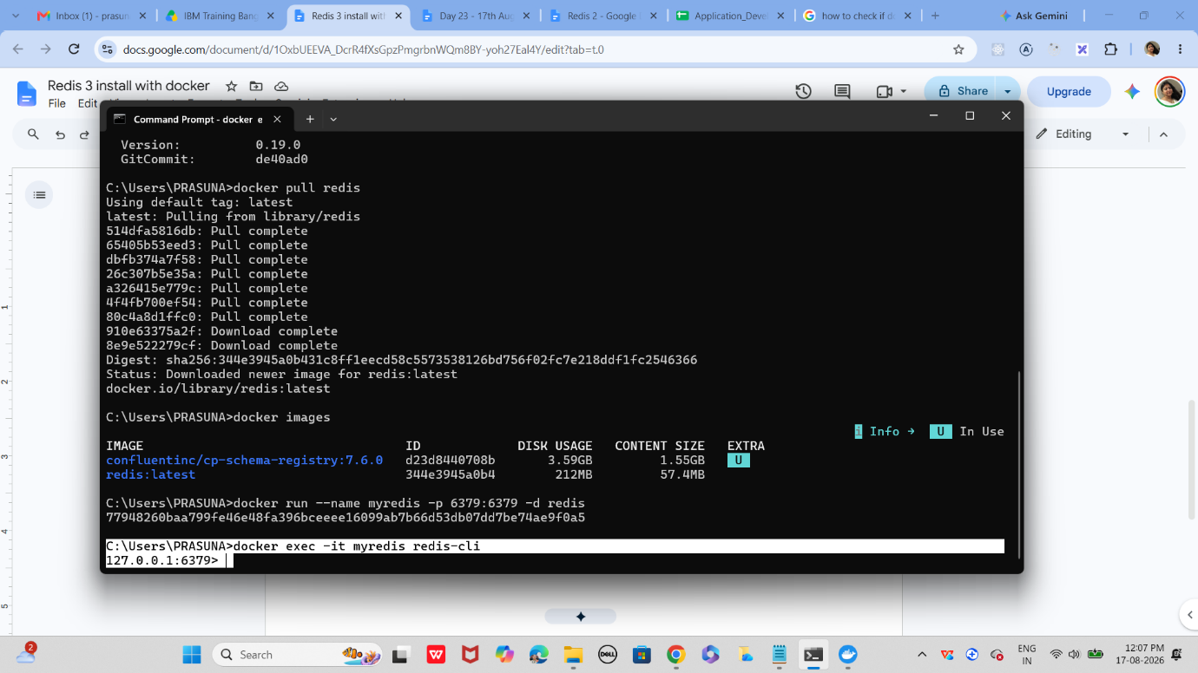

Task 8:
Type Ping
The output should be pong
Pong
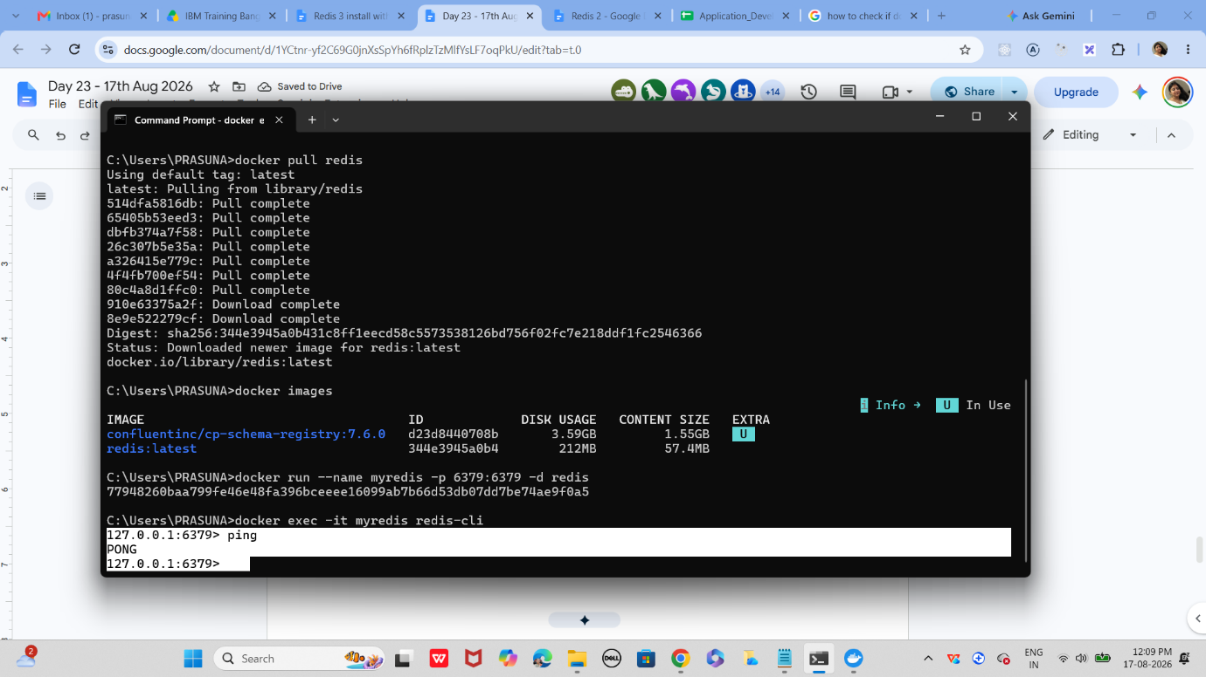

Task 9:
127.0.0.1:6379> set mykey1 "hello Prasunamba from redis"
OK
127.0.0.1:6379> get mykey1
"hello Prasunamba from redis"
127.0.0.1:6379>

Task 10:
127.0.0.1:6379> incr counter
(integer) 1
127.0.0.1:6379> get counter
"1"

Task 11:
To run hashset you need to open redis - cli
How to do that
- Use command you will see redis if its working or else it will show exit status
  - docker ps -a
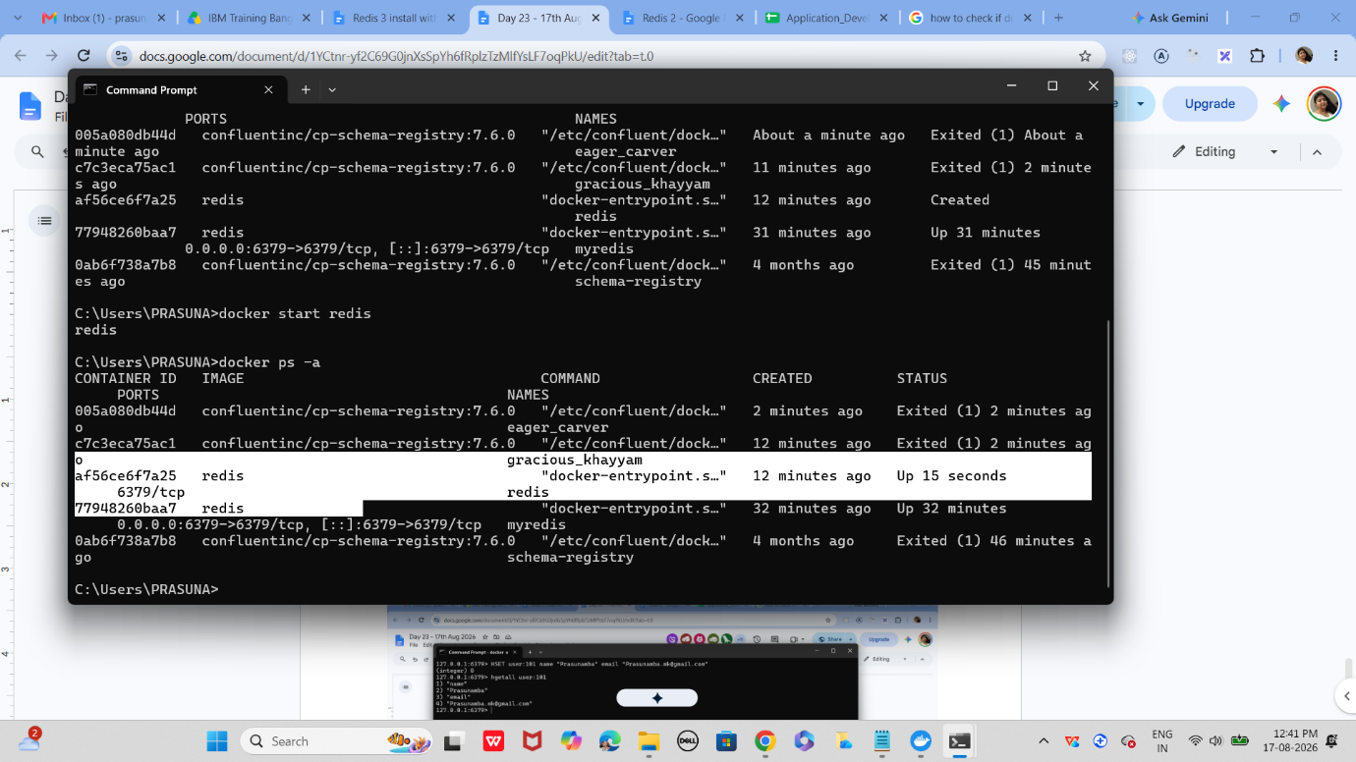

Now open another command promt
And use
HSET user:101 name "Prasunamba" email "Prasunamba.mk@gmail.com"

And get using
hgetall user:101
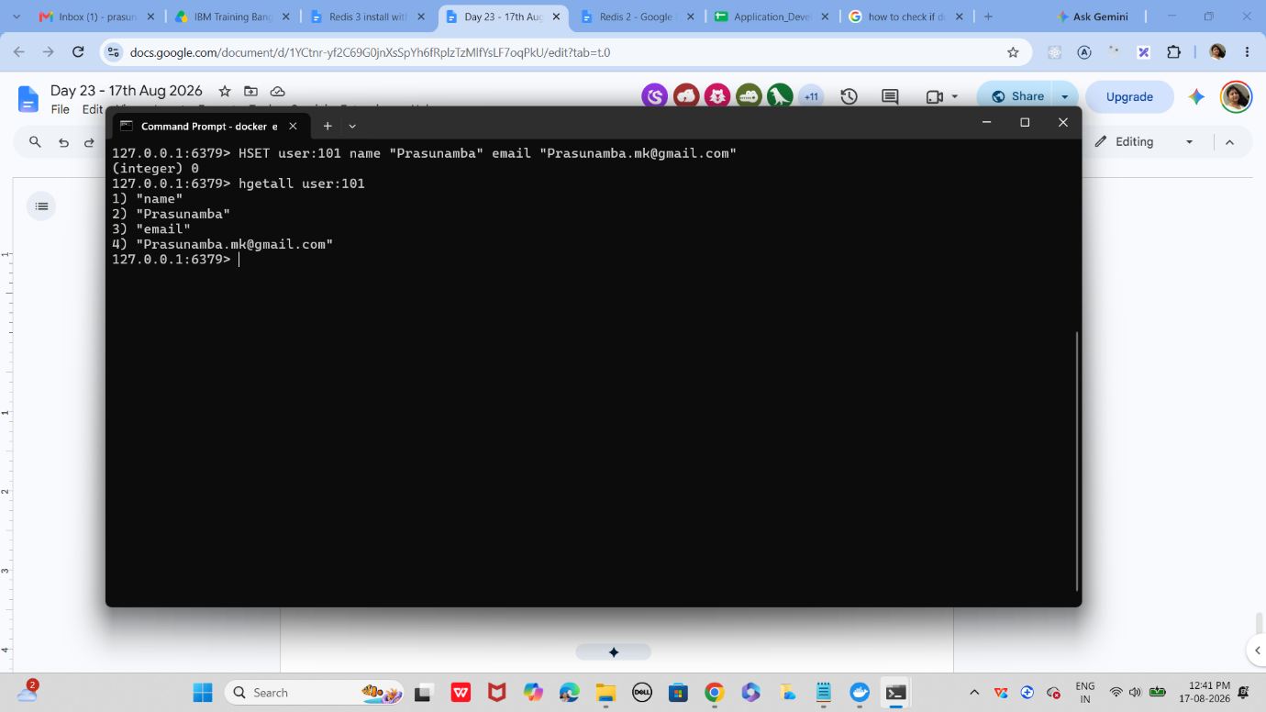

Task 12:
List of ordered collections
LPUSH tasks "Task1"
LPUSH tasks "Task2"
LRANGE tasks 0 -1
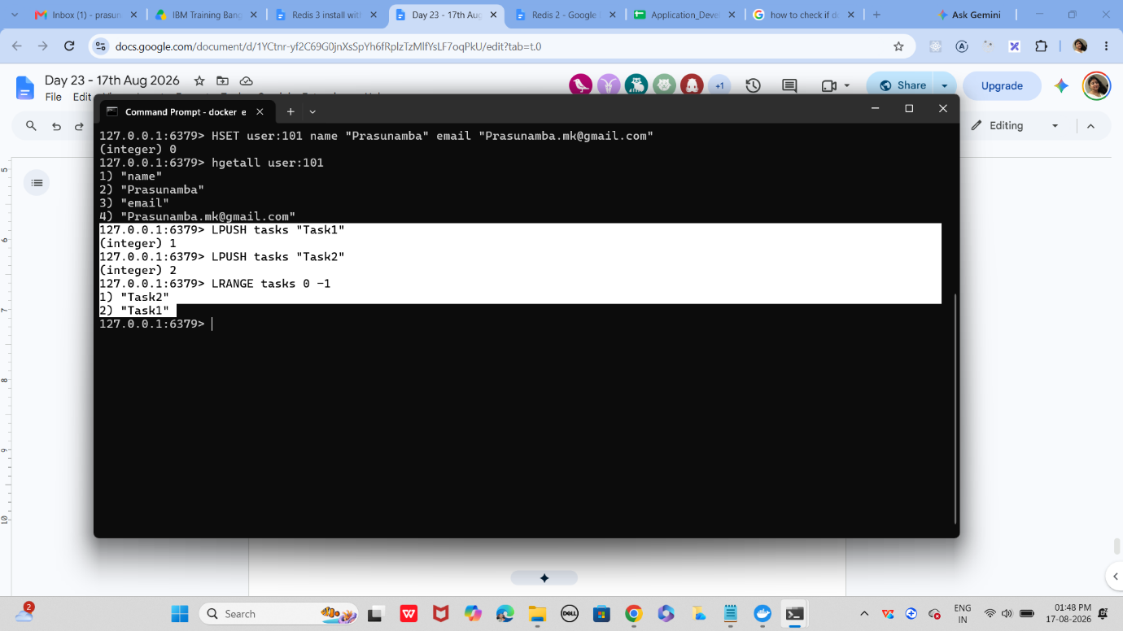
Task 13:
Sets (unique value)
SADD customrs1 "Prasunamba" "Meher" "K"
SMEMBERS customrs1
SISMEMBER customrs1 "K" (sismember is checking if the value exists or not.
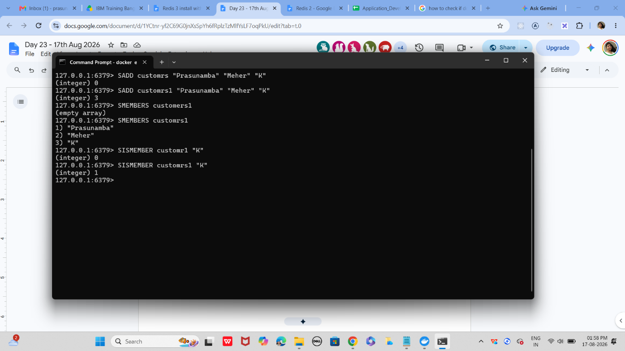

Task 14:
In the same way can you check sorted set … zsets .. what are they ?why they are used ? how to use ? cn you try ?
Like zadd leaderboard 100 “Prasunamba”
A Sorted Set is like a Redis Set + score.
- Values/members are unique.
- Each member has a score.
- Redis automatically keeps members ordered by score.
- Commonly used for leaderboards, rankings, priority queues, and score
ZADD leaderboard 100 "Prasunamba"
ZADD leaderboard 150 "Pavan"
ZADD leaderboard 80 "Rahul"

leaderboard
├── Rahul → 80
├── Prasunamba → 100
└── Pavan → 150

Task 15:
127.0.0.1:6379> set user:1 "Prasunamba"
OK
127.0.0.1:6379> exists user:1
(integer) 1
127.0.0.1:6379> del user:1
(integer) 1
127.0.0.1:6379> keys *
1) "user:101"
2) "customrs"
3) "user"
4) "tasks"
5) "customrs1"
127.0.0.1:6379> rename user:1 user:100
(error) ERR no such key
127.0.0.1:6379> rename user:2 user:100
(error) ERR no such key
127.0.0.1:6379> set user:1 "Prasunamba"
OK
127.0.0.1:6379> rename user:1 user:100
OK
127.0.0.1:6379> keys *
1) "user:100"
2) "user:101"
3) "customrs"
4) "user"
5) "tasks"
6) "customrs1"
127.0.0.1:6379> expire session:123 10
(integer) 0
127.0.0.1:6379> expire session:123 10 ttl session:123
(error) ERR Unsupported option ttl
127.0.0.1:6379> SET session:123 "active"
OK
127.0.0.1:6379> expire session:123 10
(integer) 1
127.0.0.1:6379> ttl session:123
(integer) -2
127.0.0.1:6379> expire session:123 1000
(integer) 0
127.0.0.1:6379> ttl session:123
(integer) -2
127.0.0.1:6379> expire session:123 1000000
(integer) 0
127.0.0.1:6379> ttl session:123
(integer) -2
127.0.0.1:6379> get session:123
(nil)
127.0.0.1:6379>
127.0.0.1:6379> PERSIST session:123 // checking if still persists or not 1 says yes 0 says expired.
(integer) 1

Task 17:
How does Cache-Aside balance freshness and performance, and what risks arise if the database is updated frequently?
Cache-Aside: Freshness vs Performance
- How it works: Application first checks Redis/cache → if data exists, use it (cache hit).
- If not found → read from database → put the result into cache → return it (cache miss).
- Performance: Frequently accessed data is served from cache, reducing database queries and improving response time.
- Freshness: Cache can have a TTL, so stale data is automatically removed after a period.
- Database updates: When data is updated, the application should also invalidate or update the corresponding cache entry.
Risks when the database is updated frequently
- Stale data – Cache may contain old data after the database changes.
- Cache invalidation complexity – Every database update may require updating/deleting the corresponding cache entry.
- Extra database load – Frequent invalidations cause more cache misses, sending more requests to the database.
- Inconsistent data – For a short period, Redis and the database may contain different values.
- Cache stampede – If many cached entries expire at once, many requests may hit the database simultaneously.

Task 18:
In what type of workload would Write-Behind caching introduce consistency challenges compared to Write-Through?
Write-Behind caching introduces consistency challenges in workloads where the database must always have the latest data immediately.
Workloads where this is risky
- Banking / Financial transactions – Delayed database writes could cause incorrect balances or transaction states.
- Inventory management – Stock changes must be reflected immediately to avoid selling unavailable items.
- Order processing – Delayed writes can cause incorrect order status or duplicate processing.
- Real-time pricing – Frequently changing prices need immediate database consistency.
- Critical user data – Applications where losing recently cached updates is unacceptable.

Task 19:
Why might LFU eviction be more suitable than LRU eviction in recommendation systems?
LFU (Least Frequently Used) can be more suitable because recommendation systems often benefit from keeping consistently popular recommendations in the cache.
Key points
- LFU tracks frequency – Keeps items that are requested frequently.
- Better for popular content – Frequently recommended products, movies, or articles remain cached.
- LRU focuses on recency – An item accessed recently may stay in cache even if it is rarely requested.
- Reduces repeated computation – Popular recommendations can be served directly from cache.
- Works well with stable popularity – If certain recommendations remain popular over time, LFU retains them.

Task 20:
What are the trade-offs between time-based invalidation and event-based invalidation?
How would you design cache invalidation for a real-time stock trading system?
 | Time-Based (TTL) | Event-Based
How | Cache expires after fixed time | Cache invalidated when data changes
Freshness | ⚠️ May serve stale data | ✅ Usually fresher
Complexity | ✅ Simple | ❌ More complex
DB load | Predictable | Can increase during frequent updates
Best for | Data that can tolerate some staleness | Frequently changing/critical data
Approach
- Update Redis immediately when a new market price arrives.
- Use events/message streaming to propagate price changes.
- Don't rely only on TTL because prices can become stale within milliseconds.
- Use a very short TTL as a safety mechanism, not the primary freshness mechanism.
- Use version/timestamp checks to prevent an older event from overwriting newer data.
- For critical trade execution, don't rely solely on cached data; validate against the authoritative market/order system.
- Handle duplicate or out-of-order events using sequence numbers or timestamps.

Task 21:
How would you design cache invalidation for a real-time stock trading system?
3.1 to 3.45
• Use event-based invalidation when stock prices change.
• Update Redis immediately whenever a new price arrives.
• Use a short TTL as a backup safety mechanism.
• Use timestamps or version numbers to prevent old data from overwriting new data.
• Handle duplicate or out-of-order events properly.
• Use a message broker/event stream to distribute price updates.
• For actual trade execution, verify against the authoritative trading system, not only Redis.
• Monitor cache failures and re-sync Redis when necessary.
Home task:

Task 22:
How does sharding in Redis clusters improve scalability, and what complexity does it add to key management?
• Distributes data – Data is divided across multiple Redis nodes.
• Increases memory capacity – Each node stores only part of the total data.
• Improves throughput – Requests can be processed by different nodes in parallel.
• Improves scalability – More Redis nodes can be added as data and traffic grow.
• Uses hash slots – Redis Cluster assigns keys to 16,384 hash slots.
• Key management becomes complex – Related keys may end up on different nodes.
• Multi-key operations can be difficult – Commands involving multiple keys may require those keys to be on the same node.
• Hash tags help – Using {} can force related keys into the same hash slot.

